HOW TO INITIATE YOUR CLAIM WITH TRAVEL INSURED INTERNATIONAL ONLINE

***IMPORTANT: TO INITIATE THIS PROCESS YOU WILL NEED YOUR POLICY NUMBER. THIS APPEARS ON THE CONFIRMATION OF BENEFITS THAT WAS SENT TO YOU AT THE TIME OF PURCHASE. IF YOU ARE UNSURE IF YOU PURCHASED A POLICY, YOU MAY EMAIL GROUPS@TRAVELINSURED.COM TO CONFIRM***

***THIS PROCESS IS ONLY APPLICABLE FOR POLICIES WITH CANCEL FOR ANY REASON (CFAR) COVERAGE. IF YOU ARE UNSURE WHETHER OR NOT YOU HAVE A POLICY WHICH INCLUDES CFAR, YOU MAY EMAIL GROUPS@TRAVELINSURED.COM TO CONFIRM***

***PLEASE DO NOT INITIATE THIS PROCESS IF YOUR GROUP LEADER HAS ADVISED THAT CFAR WAS PURCHASED ON BEHALF OF YOUR ENTIRE GROUP. YOU WOULD HAVE BEEN INFOMED BY YOUR GROUP LEADER IF THIS WERE THE CASE. IF YOU ARE UNSURE IF CFAR WAS PURCHASED ON BEHALF OF YOUR WHOLE GROUP, PLEASE CONTACT YOUR GROUP LEADER FROM YOUR SCHOOL***

- GO TO WWW.TRAVELINSURED.COM

- CLICK ON “FILE A CLAIM”

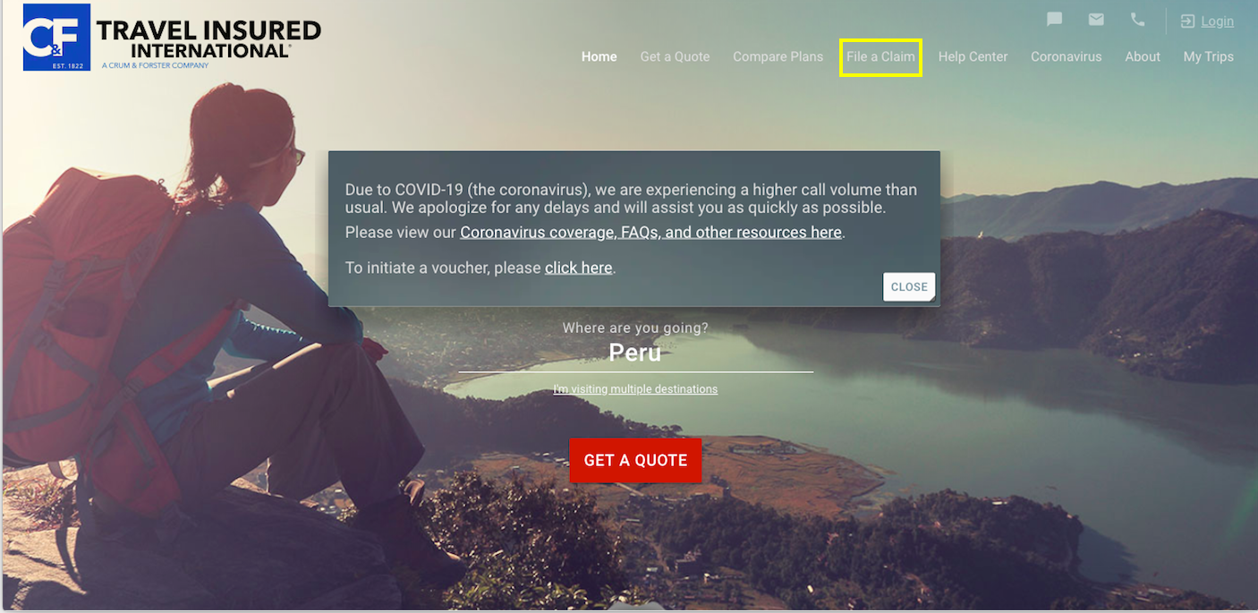

- CLICK “SUBMIT CLAIM AS A GUEST”

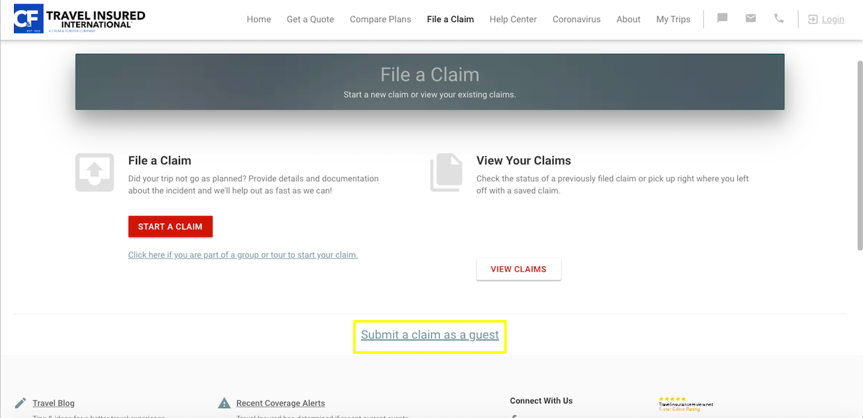

- CLICK “START YOUR CLAIM”

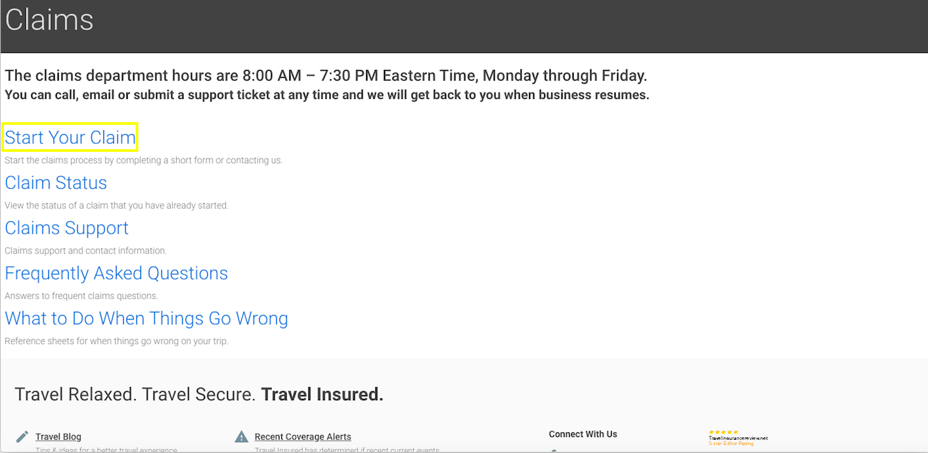

- ENTER YOUR PLAN NUMBER AND LAST NAME AS THEY APPEAR ON YOUR CONFIRMATION OF BENEFITS. THIS DOCUMENT WAS SENT TO YOU AT THE TIME YOU PURCHASED YOUR POLICY. IF YOU CANNOT LOCATE YOUR POLICY NUMBER, YOU MAY CONTACT GROUPS@TRAVELINSURED.COM FOR ASSISTANCE.

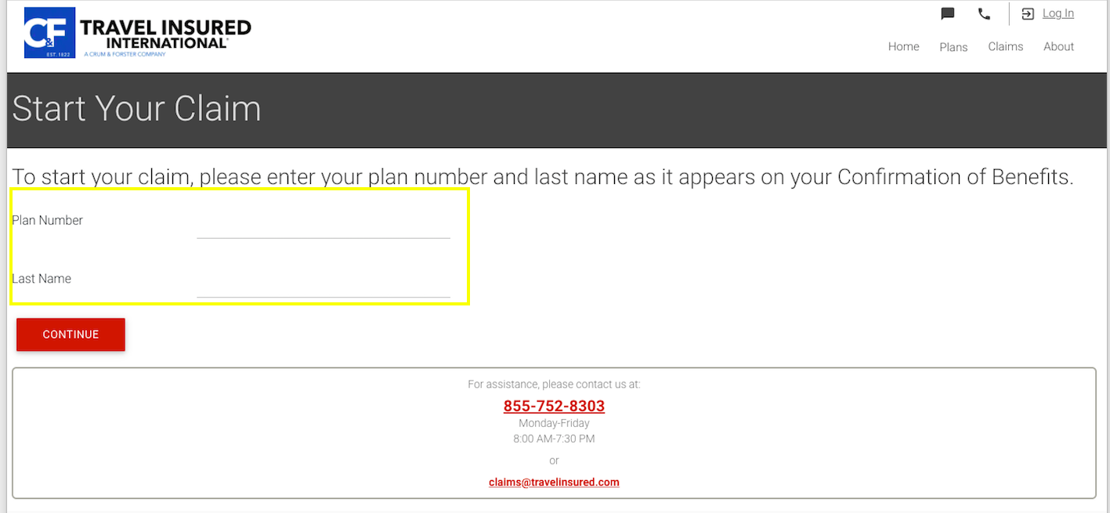

- FOLLOW THE PROMPTS TO INITIATE YOUR CLAIM. IF YOU HAVE ANY QUESTIONS PLEASE CONTACT GROUPS@TRAVELINSURED.COM.

***PLEASE NOTE THAT YOU SIMPLY NEED TO INITIATE YOUR CLAIM AT THIS TIME. AT THIS TIME, YOU MAY DISREGARD ANY AUTOMATED CORRESPONDENCE FROM TRAVEL INSURED INTERNATIONAL REQUESTING FURTHER DOCUMENTATION.***

